1. Dimension Master
Definition: A single source of truth containing every dimension that controls your robotic arm.
Mechanism: Instead of randomly measuring things while modelling, we establish the important dimensions first and use those dimensions throughout Fusion.
Real-World Use-Case: If we later discover that your servo mounting-hole spacing is different, we change one parameter and the related bracket/link geometry can be updated.
I want us to eventually have a table like:
Component | Dimension | Value | Source
MG996R | Body length | TBD | Physical measurement
MG996R | Body width | TBD | Physical measurement
MG996R | Body height | TBD | Physical measurement
MG996R | Mounting-hole spacing | TBD | Physical measurement
MG996R | Mounting-hole diameter | TBD | Physical measurement
MG996R | Output shaft height | TBD | Physical measurement
MG996R | Spline type | TBD/verified | Servo specification
Horn | Outer diameter | TBD | Physical/CAD measurement
Horn | Thickness | TBD | Physical/CAD measurement
Horn | Hole-circle diameter | TBD | Physical/CAD measurement
Horn | Hole diameter | TBD | Physical/CAD measurement
Link 1 | Length | TBD | Our design
Link 1 | Width | TBD | Our design
Link 1 | Thickness | TBD | Our design
Link 2 | Length | TBD | Our design
... | ... | ... | ...
TBD is intentional.
I don't want to give you a number just because it appears on some random MG996R webpage.

2. The MG996R becomes our mechanical reference
This is probably the most important component in the entire arm.
Your arm isn't going to be:
Link → servo somehow
It should be:
SERVO
│
┌──────────┴──────────┐
│ │
Servo body Output shaft
│ │
mounting horn
geometry │
│ │
└──────────┬──────────┘
│
ARM LINK
Every mounting feature on our printed parts should be designed around the actual servo geometry.

3. We need to distinguish THREE kinds of dimensions
This is very important.
A. Manufacturer dimensions
These come from reliable specifications/datasheets.
Example:
Servo body dimensions
Spline specification
Operating angle
Torque
B. Physical measurements
These are dimensions we should measure from the actual servo/horn you will use.
For example:
Mounting-hole diameter
Hole-to-hole distance
Horn thickness
Shaft protrusion
Actual body dimensions
C. Our design dimensions
These are things we decide:
Link length
Link thickness
Bracket thickness
Fillet radius
Wall thickness
Bearing clearance
We should never confuse these three.

4. Physical measurement is going to be VERY important
This is the part I don't want us to skip.
If you have the actual MG996R servo with you, the best tool would be a:
Digital Vernier Caliper
Something like:
Digital Vernier Caliper
┌────────────────────────┐
│ 25.43 mm │
└────────────────────────┘
\ /
\ /
────────────
With it, we can measure the physical servo to around 0.01 mm display resolution, although the practical accuracy depends on the caliper, technique, and surface.
If you don't have a caliper, we can still start with CAD/reference dimensions, but before printing the final parts I strongly recommend measuring the actual hardware.

5. Servo Horn
We've now got this beautiful circular horn in Fusion:
○ ○ ○
○ ○
○ ◎ ○
○ ○
○ ○ ○
But before attaching it permanently to the servo model, we'll verify:
Center spline
Does the horn actually fit the MG996R's output spline?
Outer diameter
How far does the horn extend?
Thickness
How thick should our mating component be?
Hole pattern
This is extremely important because your arm link may attach through those holes.
Hole diameter
We need to know what screw will actually pass through them.

6. Mechanical clearance
This is where 3D printing becomes different from simply modelling.
Suppose we model:
Screw = 3.00 mm
Hole = 3.00 mm
That doesn't necessarily mean the screw will comfortably pass through a printed hole.
We may instead need something like:
Nominal screw
↓
3.00 mm
↓
Printed clearance hole
↓
slightly larger
The exact clearance depends on:
- printer
- nozzle
- material
- layer height
- print orientation
- whether the hole is intended to be loose or tapped
So we will distinguish:
NOMINAL DIMENSION
↓
MANUFACTURING CLEARANCE
↓
FINAL PRINTED DIMENSION

7. Wall thickness
For your arm links, we shouldn't simply make a thin decorative shell.
We'll think about:
Link
┌─────────────────┐
│ │
│ internal │
│ structure │
│ │
└─────────────────┘
We'll consider:
- load
- servo torque
- bending
- weight
- printability
- infill
- layer orientation
- screw mounting
- stress concentration
Because your MG996R can produce significant torque, the joint areas deserve special attention.

8. Joint design
This is where the arm becomes an actual robot.
For example:
LINK 2
│
│
┌────┴────┐
│ JOINT │
│ MG996R │
└────┬────┘
│
LINK 1
We'll determine:
- rotation axis
- servo position
- horn position
- link centerline
- mounting brackets
- screw locations
- mechanical stops
- collision envelope

9. We also need to calculate the arm before printing
This is something I particularly want us to do.
Suppose eventually we have:
Base
│
├──── Link 1 = L1
│
├──── Link 2 = L2
│
└──── Link 3 = L3
We'll calculate the arm's:
Reach
How far can the end effector reach?
Payload
How much weight can the arm realistically handle?
Torque
How much torque does each joint need?
Center of mass
Where does the weight of the links and payload act?
Servo loading
This is critical because a servo may have enough torque at one joint but become overloaded at another.

10. Then we design the actual Fusion model
Our Fusion project can eventually become:
ROBOTIC ARM
│
├── MASTER PARAMETERS
│
├── BASE
│
├── WAIST
│
├── JOINT 1
│ ├── MG996R
│ ├── Horn
│ └── Mount
│
├── LINK 1
│
├── JOINT 2
│ ├── MG996R
│ ├── Horn
│ └── Mount
│
├── LINK 2
│
├── JOINT 3
│
├── LINK 3
│
└── END EFFECTOR
And importantly, we'll make the printed parts separate components.
That makes:
- editing easier
- exporting STL easier
- assembly easier
- printing easier
- replacement easier

🖨️ 11. Before we print anything
We will do a complete Print Readiness Check.
☐ Dimensions verified
☐ Servo mounting verified
☐ Horn fit verified
☐ Screw holes verified
☐ Clearances verified
☐ Joint axes verified
☐ No component collisions
☐ Full arm motion checked
☐ Servo torque checked
☐ Link strength considered
☐ Print orientation selected
☐ STL exported
☐ Test-fit part printed
And I strongly recommend:
Don't print the entire arm first.
We'll print small test pieces.
For example:
MG996R mounting bracket
↓
PRINT
↓
Test actual servo fit
↓
If correct → final bracket
That can save a huge amount of filament and time.

⭐ One major rule for our project
From this point onward:
No guessed dimensions for parts that physically mate with another component.
If a dimension affects:
servo ↔ bracket
or
horn ↔ link
or
screw ↔ hole
or
bearing ↔ shaft
we'll verify it.
We can use the CAD model as a starting reference, but the actual hardware gets the final word.

And your current setup is actually a great starting point
You now have:
YOUR ROBOTIC ARM
│
┌───────────┴───────────┐
│ │
REAL HARDWARE CAD MODELS
│ │
MG996R Servo MG996R Fusion
Servo Horn Servo Horn
Electronics Reference Arm
│ │
└───────────┬───────────┘
│
▼
MASTER DESIGN
│
▼
3D PRINTABLE ARM

Complete Dimensions( from google)
- Length: 40.7 mm
- Width (Thickness): 19.7 mm
- Height: 42.9 mm
- Weight: 55 g

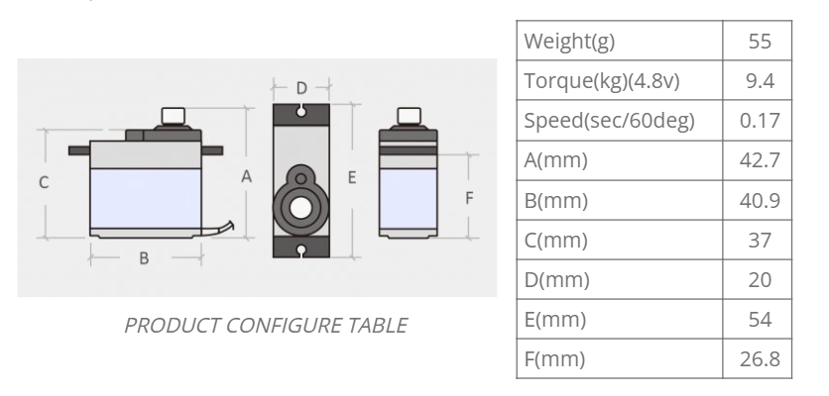

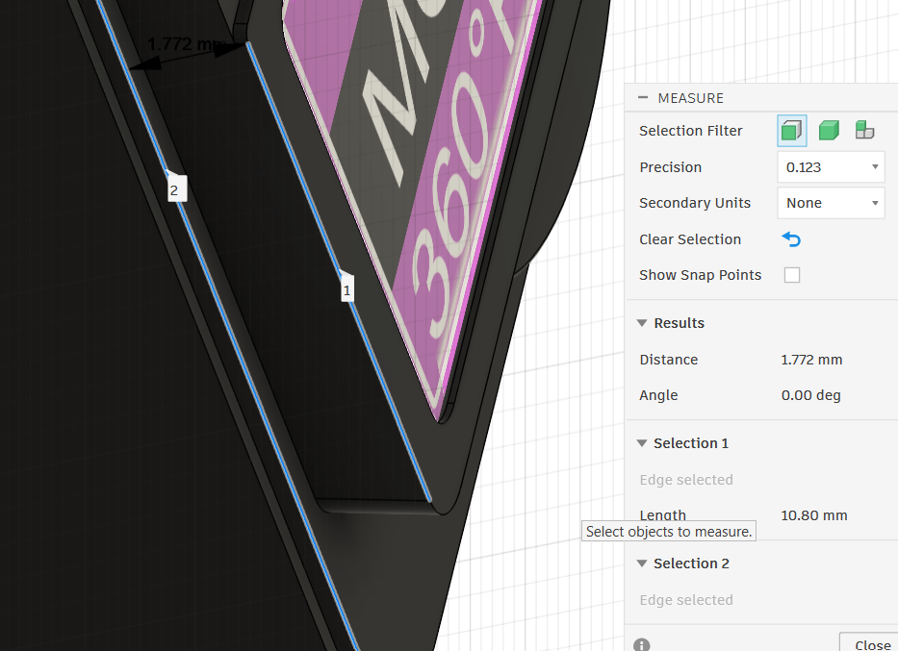
MG996R Servo

One important distance :1.772

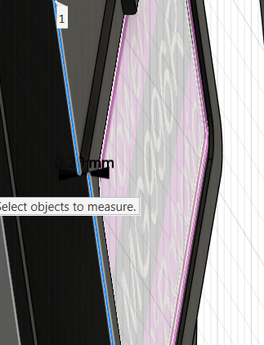
one more important distance :0.2mm

- Body length = 40mm
- Body width = 19mm
- Body height = 37.50mm
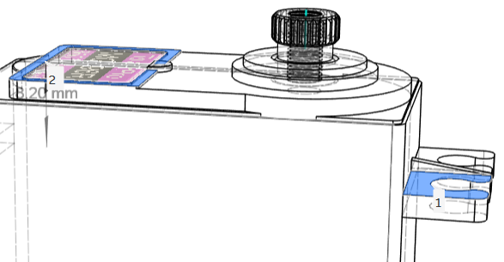
Mounting-hole spacings:
- Mounting-interface offset = 8.20mm

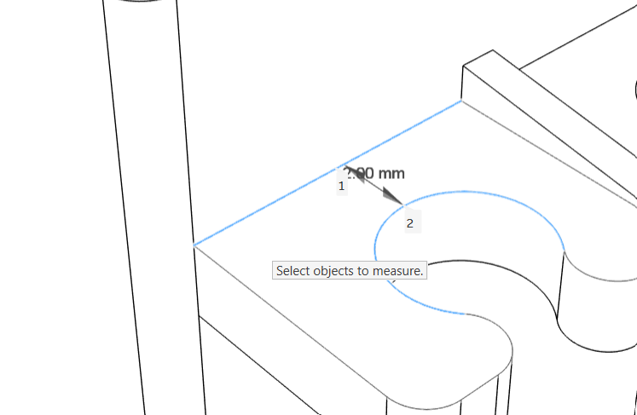
- mounting hole distance (1)=2mm

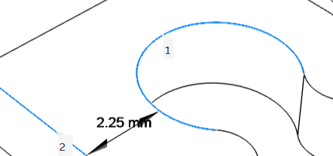
- mounting hole distance (2)=2.25mm

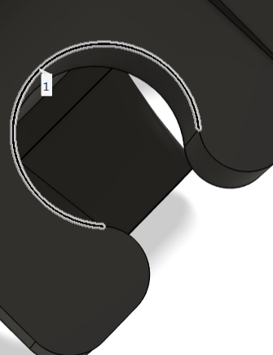

- . Servo mounting-hole diameter =4mm

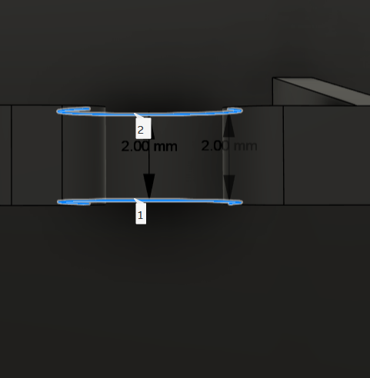
- Horn hub height =2mm

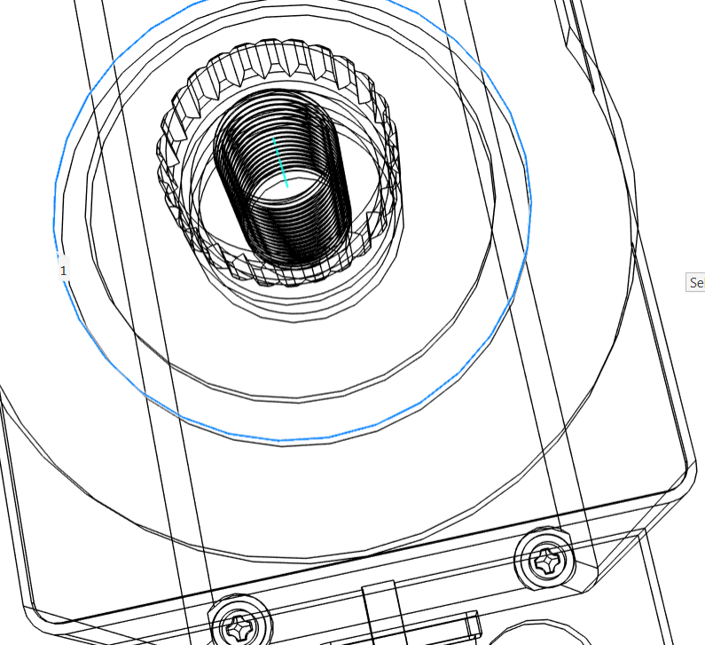
- servo output spline circle’s outer most diameter=13mm

- output spline length from the servo body=5.70mm

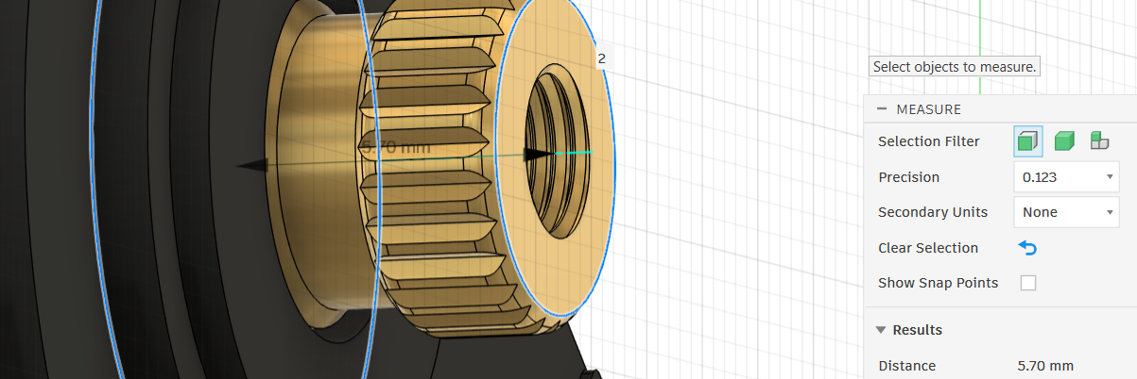

- put spline center diameter =//

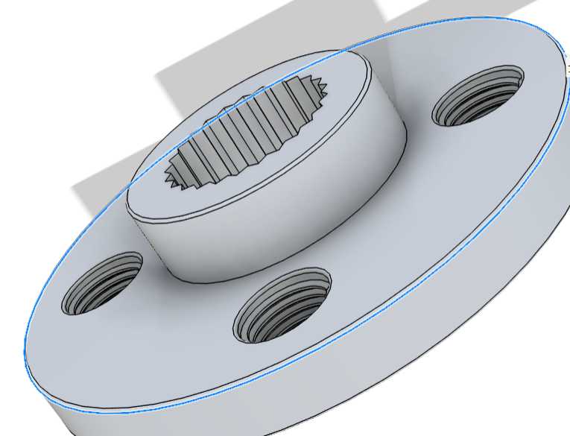
Servo Horn
- Outer diameter = 20.00 mm

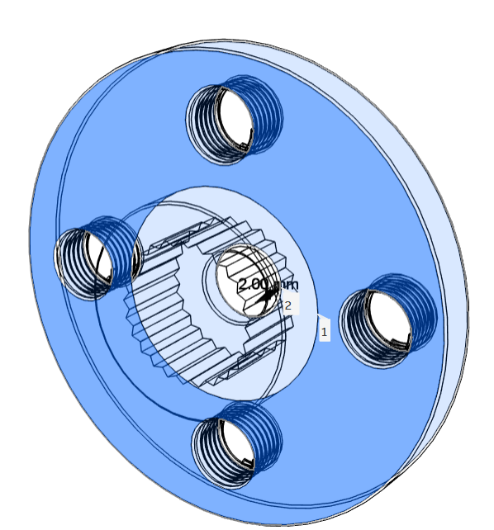

- Plate thickness = 2.00 mm

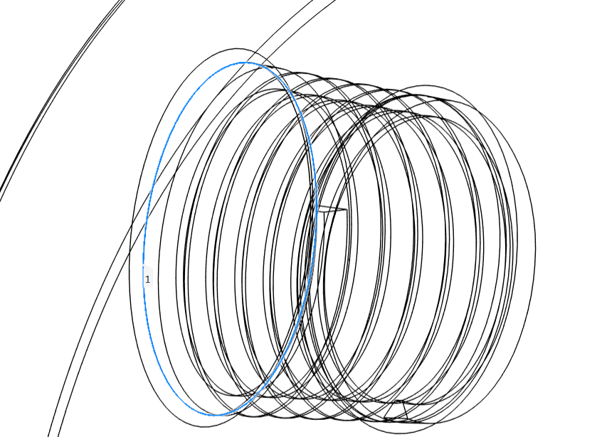
- horn borscrew diameter=3mm

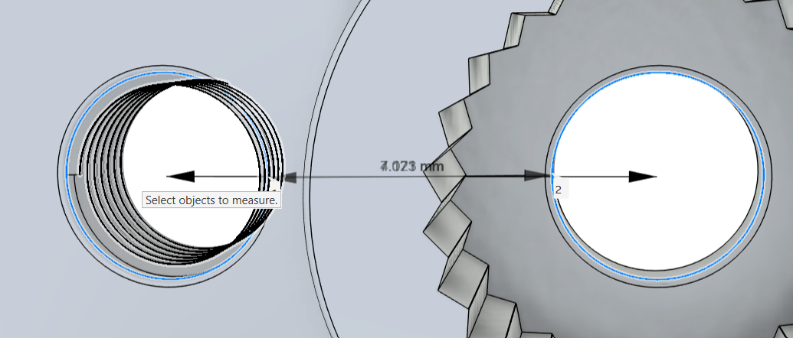
4) distance between two borscrew =7.071

Robot Arm
- DOF = 6
- Servos = 6 × MG996R
- Link 1 length = ___
- Link 2 length = ___
- Link thickness = ___
- Joint clearances = ___
- Fasteners = ___
- Bearing arrangement = ___

